Trade History for Project

1. Vedanta Limited

-P/S: 0.69 -VAP_Earnings>LTP

-Dividend Record:

-Current position:

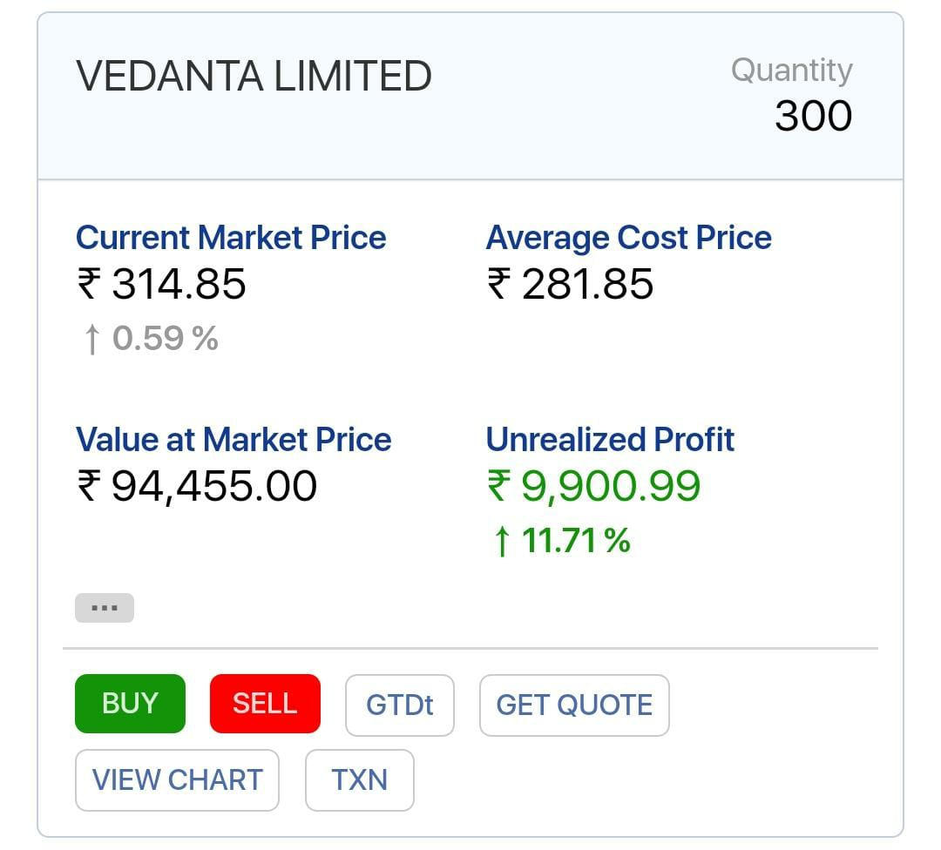

1. Axiscades Technology

-P/S: 0.7 -VAP_GRAHAM(106) >LTP

-P/B: 1.1

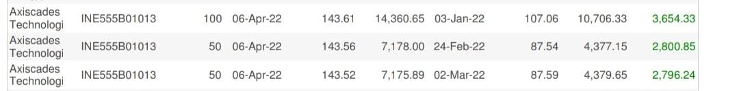

1. Hindustan Zinc:

-Dividend Yield: 14%

-Profit Margin: 32%

-Dividend Record:

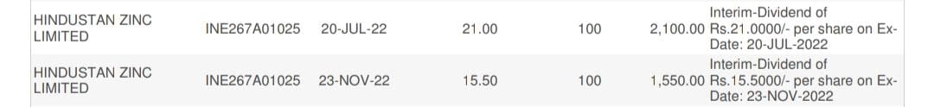



1. Time Technoplast:

-P/S: 0.40

-P/B: <1

-VAP_Earnings(120)>LTP

1. Tanfac Industries:

-RoE: 49%

-P/S:<1.9

-VAP_Earnings>LTP

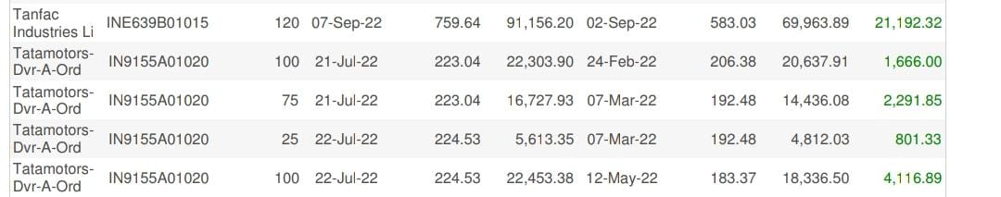

1. Repco Home Finance

-P/S:<1

-P/B:<1

-VAP_Earnings(465)>LTP



1. Cochin Shipyard:

-P/B: <1.5

-VAP_Graham(560)>LTP

-VAP_Earnings(630)>LTP



1. Manaksia:

-P/S:<1

-P/B:<1

-VAP_Earnings>LTP

-VAP_Graham>LTP



1. Surya Roshni:

-P/S:<0.5

-P/B:<1.5

1. Silver ETF:

-Sentiment Analysis: 5g trend, green energy push

